# CS 255 Business Requirements Document Template

Complete this template by replacing the bracketed text with the relevant information.

This template lays out all the different sections that you need to complete for Project One. Each section has guiding questions to prompt your thinking. These questions are meant to guide your initial responses to each area. You are encouraged to go beyond these questions using what you have learned in your readings. You will need to continually reference the interview transcript as you work to make sure that you are addressing your client’s needs. There is no required length for the final document. Instead, the goal is to complete each section based on your client’s needs.

**Tip:** You should respond in a bulleted list for each section. This will make your thoughts easier to reference when you move into the design phase for Project Two. One starter bullet has been provided for you in each section, but you will need to add more.

## System Components and Design

### Purpose

* Our client is DriverPass. DriverPass has tasked us with developing a software that can store data for their customers. The customer must be able to interact with the software from any location that has access to the internet and can sign into their account to view data tracking their progression, user data and training package, and can allow them to schedule meetings with trainers to continue in their training.

### System Background

* DriverPass wants the system to work as a fully functional interface for their customers to order their services, and also wants the system to track and customer and order information to be able to report in depth details and data for orders. DriverPass noticed that “so many people fail their driving tests at the DMV. [Liam is] starting this company to provide this training for [his] customers”. This system will need to account for a user interface, a backend, and a function to report information to specified employees of DriverPass.

### Objectives and Goals

* This system should be accessible from any computer or mobile device that has access to the internet.
* Ian must have full access over all accounts.
* Must be capable of tracking reservation information in detail: who ordered, when, where, what trainer, and what car.
* Users must be able to make appointments, cancel, and modify appointments online.
* Must offer three package deals to the customer for ordering, with the capability to add or modify modules should they change them in the future.
* Registration for the system should take place over the phone, including data such as first name, last name, address, phone number, state, pickup/drop-off location, and credit card information (number, exp date, & security code).
* Must alert DriverPass when the DMV changes their requirements.
* Must be a cloud based system.
* UI should adhere to Ian’s preferred stylization, displaying information to user such as progress, test names, times taken, scores, and statuses (in progress, failed, or passed). This must be able to be altered by the user or the secretary helping the user.

## Requirements

### Nonfunctional Requirements

#### Performance Requirements

* DriverPass I required to run off of the Web over a cloud based system. The system doesn’t require high performance, but it should be updated as often as a user changes their settings or as often as the DMV changes an requirements to getting a liscence.

#### Platform Constraints

* The platform should run on all systems that have access to the Web, but only needs to be accessed through the Web (i.e., no apps). Cloud based storage should be implemented for this system.

#### Accuracy and Precision

* Each user will have a case-sensitive username and password, as well as have information stored in their profile such as first name, last name, address, phone number, state, pickup/drop-off location, and credit card information. The system need not immediately report problems to the admin, but the admin should have access to activity reports that should be printable and record data such as records of reservation including who make it, who cancelled it, and who last modified it as well as when these changes occurred.

#### Adaptability

* The user should be able to reset their password by themselves or by calling the secretary. The user should also be able to change their user information through a phone call with the secretary or by themselves through the website and the system should be capable of running on the Web at all times. The IT admin needs access to all of the code and profiles aside from the bosses profile.

#### Security

* In terms of security, the user is required to have the correct case-sensitive username and password to access their account. The owner should have access to all accounts in case of any fraudulent activity and the users should have access to a contact list of the employees in case they have any issues accessing their account, including forgetting their password.
* Security of data exchange must have implementations in place to prevent prying eyes from viewing information not public to them.
* There should be some implementation to combat “brute force” hacking attempts, whether it be a backdoor or kill switch, etc.
* Security of data exchange as well as “brute force” hacking attempts were not specifically covered in the primary interview and require a follow-up interview to be fleshed out.

### Functional Requirements

* The system shall allow for multiple kinds of users.
* The system shall require user credentials when logging in.
* The system shall have a method of reserving driving lessons in varying kinds of offered packages.
* The system shall be capable of tracking and displaying user progression through online tests.
* The system shall record reservation history and be capable of compiling reservation history into printable activity reports
* The system shall store unique personal user information, including first name, last name, address, phone number, state, pickup/drop-off location, and credit card information, and allow users to change personal user information should they choose to.
* The system shall have a methodology of restoring lost accounts (whether it be from forgetting a password or being hacked).
* The system shall have preventative measures in place to combat hacking attempts
* The system shall be capable of giving updates to certain users as to when the DMV has changed requirements or standards for driving licenses.
* The system shall display employee contact information to users and user contact information to employees.

### User Interface

* The different users include the boss (Liam), the IT Officer (Ian), the secretary, and the primary user (the student).
* The interface should allow a user to reserve a driving lesson, view reservation history, access contact information for the employee and the user, print activity reports for those who authorized to do so, change personal user information, view online test progress, display driver and student photos lesson time charts (including total time, start time, end time, and teacher notes).
* The user should be able to access the website through any device that has access to the Web.

### Assumptions

* We assumed that the IT Officer should have total access to the system in order to make any necessary changes or adjustments, even though it was not specifically stated.
* We assumed that security of data from hacking would be a necessity as personal information could be lost otherwise, even though that topic was not specifically covered in the initial interview.
* We assumed a limitation due to budget as there is no such thing as an infinite budget.

### Limitations

* Limitations we assume would include budget and time, but should be discussed further before drawing any conclusions.

**Technical Requirements**

* The only hardware required includes computers or any devices that can access the internet for the users. For the teachers, they have to have access to some sort of car or vehicle that they can teach students to drive in. We opted out of using a physical server, so there are no hardware requirements for the server.
* Software required includes any kind of web browser.
* The only required tools include cellular devices to keep in touch with teachers during sessions, and vehicles to drive in.
* Infrastructure is taken care of thanks to no in house server.

### Gantt Chart

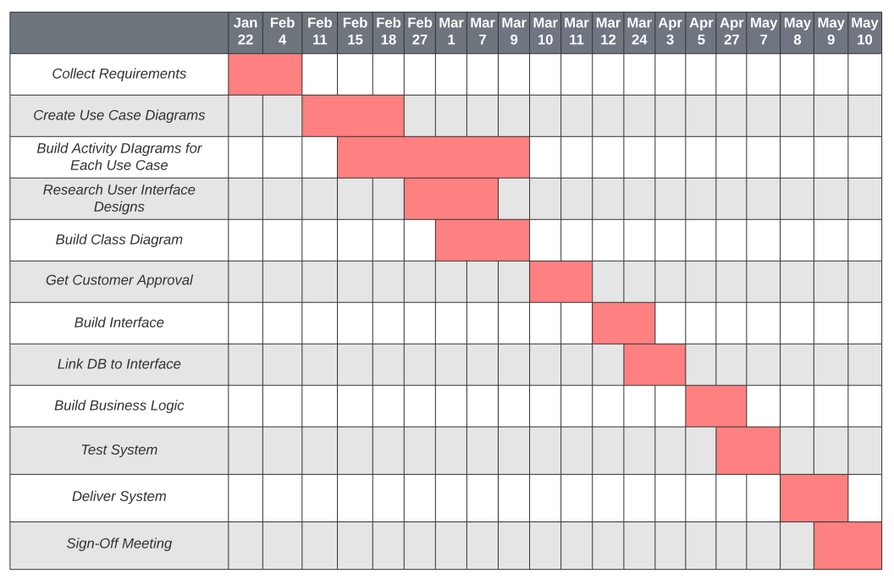

**DriverPass Use Case Diagram**

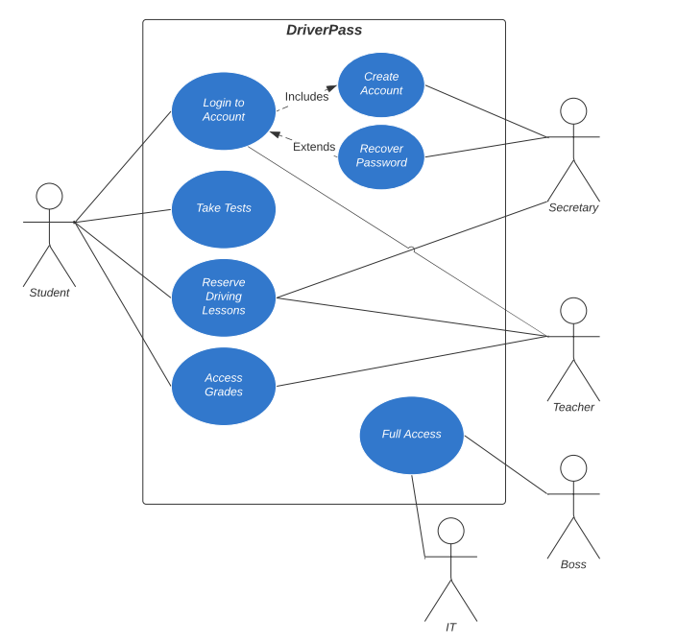

**DriverPass UML Class Diagram**

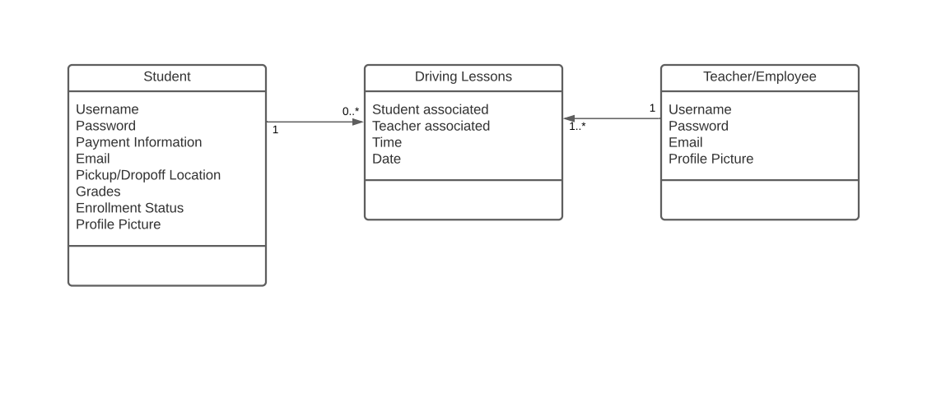

**DriverPass Account Creation UML Activity Diagram**

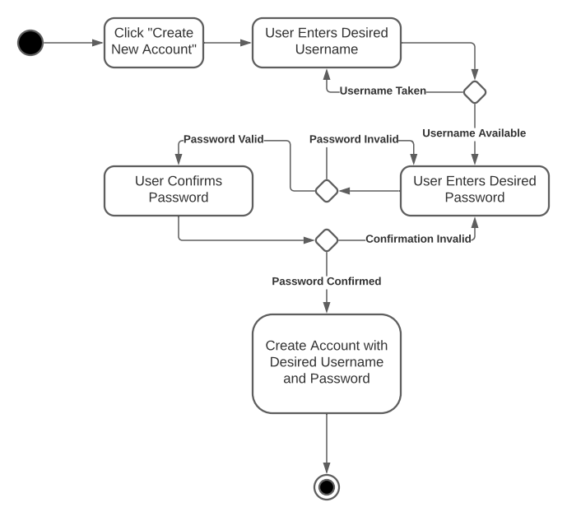

**DriverPass Account Recovery UML Activity Diagram**

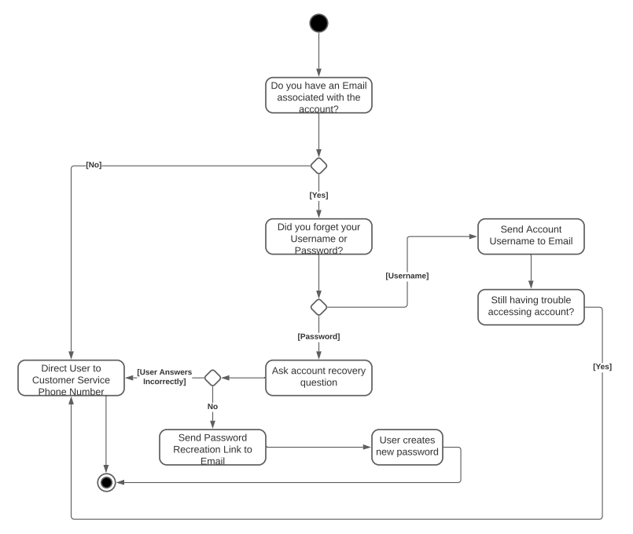

**DriverPass Account Creation UML Sequence Diagram**

